TECHNICAL REFERENCE
MTObjects Toy-Object Optimisation
Objective Function and Core Metrics
Purpose: Explain how recovery and masking are measured, combined and supplied to Optuna.
Methodology basis: paired-toy-metrics-displayed-frame-v2; MTObjects detection on the original centred image.
Prepared: 31 August 2026

In one sentence
Optuna searches for MTObjects parameters that recover injected toys, cover their truth pixels, and avoid masking too much of any displayed galaxy frame.

1. Overview
Synthetic foreground objects (toys) are inserted at known positions in clean galaxy images. MTObjects produces a mask, and the mask is compared with the known injected truth. The optimisation is deliberately constrained: a configuration is not considered scientifically useful merely because it masks every toy if it also removes substantial galaxy structure.
The calculation uses incremental masking: the mask obtained from the toy-injected image is compared with the baseline mask from the corresponding image without toys. Only newly masked pixels contribute to toy recovery. This prevents pre-existing detections from being credited as successful toy recovery.
Symbol | Meaning | Aggregation
D | Toy detection rate | All toys across all training galaxy/seed cases
R̄toy | Mean per-toy recall | Mean of individual toy recalls
Mmax | Maximum displayed-frame masked fraction | Worst galaxy/seed case
M̄ | Mean displayed-frame masked fraction | Mean across cases
F̄ | Mean pixel-level F-score | Mean across cases
FP̄ | Mean false-positive masked fraction | Mean across cases

2. Metric 1 — Toy detection rate
D = number of toys with incremental recall ≥ 0.50 / total number of toys

A toy counts as detected only when at least half of its known truth-mask pixels are covered by the incremental MTObjects mask. Detection is therefore a per-object pass/fail measure; a toy with 49% recall is missed, while one with 50% recall is detected.
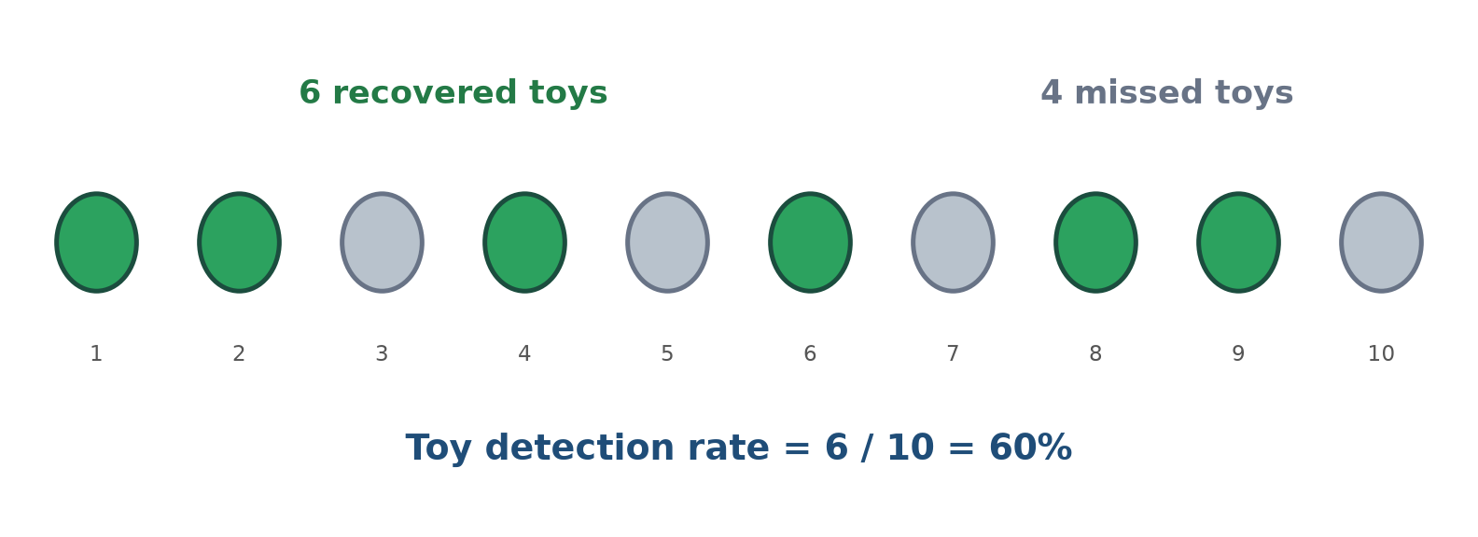
Figure 1. Toy detection rate counts recovered objects, not recovered pixels.
Interpretation
Detection rate answers: “How many injected objects were recovered well enough to count?” It does not distinguish a barely detected toy (50% recall) from a nearly complete one (95% recall).

3. Metric 2 — Mean toy recall
Recalli = incremental mask pixels inside toy i truth / truth pixels belonging to toy i
R̄toy = (Recall1 + Recall2 + … + RecallN) / N

Recall is continuous from 0 to 1. It measures how completely each injected toy is covered. The mean is calculated across toys, so every toy contributes equally regardless of its pixel area. This complements detection rate by rewarding more complete masks even after the 50% detection boundary has been crossed.
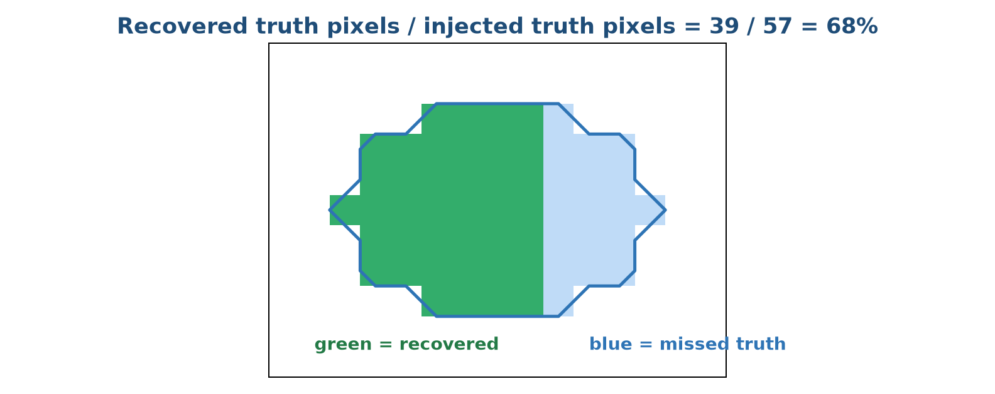
Figure 2. Per-toy recall measures completeness of coverage within the known injected truth.
Why both D and R̄toy?
Detection rate prevents many weak partial overlaps from appearing successful. Mean recall then distinguishes parameter sets that detect the same number of toys but recover different proportions of their shapes.

4. Metric 3 — Maximum displayed-frame masking
Mj = incremental masked pixels inside displayed analysis frame j / finite pixels in that frame
Mmax = maximum(M1, M2, …, MJ)

Masking is measured only inside the displayed, deprojected, galaxy-centred analysis square—the same area used for visual cleanliness review and toy placement. Pixels elsewhere in a larger FITS mosaic do not dilute the percentage.
The objective uses the maximum across galaxy/seed cases, not the mean, as its hard 15% constraint. A method cannot compensate for severe damage to one galaxy by masking very little in the others.
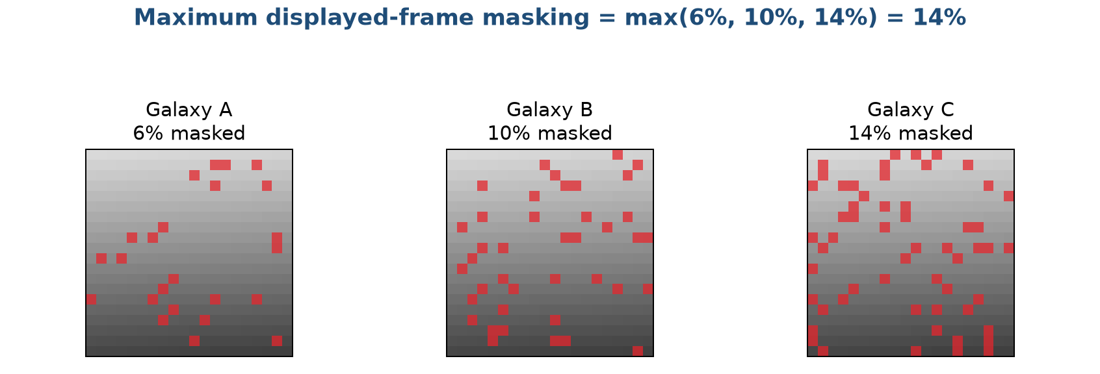
Figure 3. The worst displayed-frame masking controls feasibility.
Current constraint
Training configurations must satisfy Mmax ≤ 0.15. This is a safeguard against an apparently good average result that destroys structure in a single galaxy.

5. Supporting recovery metric — Pixel-level F-score
Precision P = TP / (TP + FP)
Pixel recall R = TP / (TP + FN)
F = 2PR / (P + R) = 2TP / (2TP + FP + FN)
F̄ = mean of the per-case F-scores

For one galaxy/seed case, TP is an incremental masked pixel that lies inside the combined toy-truth mask. FP is an incremental masked pixel outside that truth. FN is a toy-truth pixel that the incremental mask missed—the blue region in Figure 4. TN is a non-toy pixel that correctly remains unmasked—the white area outside both the blue truth boundary and the red/green mask. Precision asks how much of the new mask is relevant; pixel recall asks how much of the combined toy truth was covered.
Why true negatives are absent from F
TN does not appear in precision, recall or F. The displayed frame contains very many ordinary non-toy pixels, so a model could obtain an apparently excellent accuracy simply by leaving most of the frame unmasked while detecting no toys. F deliberately concentrates on the positive class: toy pixels that should be masked.

The F-score is their harmonic mean. It is high only when both precision and recall are high: aggressive masking cannot obtain a good F merely by covering all toy pixels, and a tiny but perfectly placed mask cannot obtain a good F while missing most of the toys. F is calculated separately for every galaxy/seed case and then averaged, so F̄ gives each case equal weight.
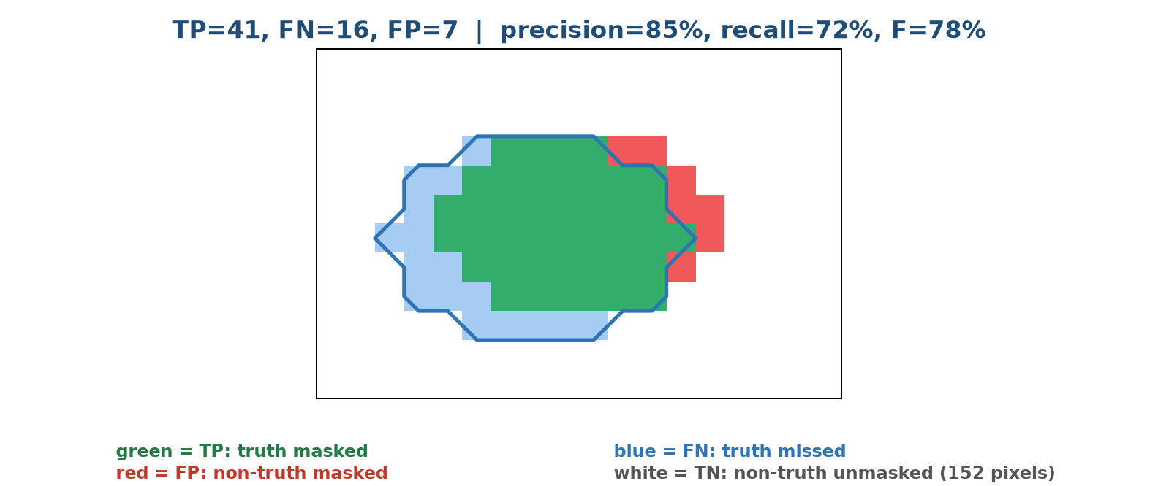
Figure 4. The same pixel classification supplies precision, pixel recall, F and FP.
Difference from mean toy recall
Pixel recall pools all toy-truth pixels in a case, so larger toys contribute more pixels. Mean toy recall first calculates recall for each toy and then averages the toys equally. F additionally includes precision, whereas mean toy recall does not.

6. Supporting data-loss metric — False-positive masked fraction
FP fraction = incremental masked pixels outside toy truth / non-toy pixels in the displayed frame
FP̄ = mean of the per-case FP fractions

The numerator is the red area in Figure 4: newly masked pixels that cannot be attributed to an injected toy. The denominator is every non-toy pixel in the displayed analysis frame, equal to displayed-frame pixels minus toy-truth pixels. The metric therefore estimates the fraction of available galaxy/background area removed unnecessarily.
FP fraction is not the same as 1 − precision. One minus precision divides false-positive pixels by all incremental masked pixels; the implemented FP fraction divides them by all non-toy pixels in the displayed frame. For example, if 30 of 100 new mask pixels are outside the toys, precision is 70% and 1 − precision is 30%. If the frame contains 10,000 non-toy pixels, however, the implemented FP fraction is 30/10,000 = 0.3%.
Why include both M̄ and FP̄?
M̄ measures the total incremental mask as a fraction of the displayed frame, including useful toy coverage. FP̄ isolates masking outside the known toys. Their penalties overlap deliberately but answer different questions: total image loss versus demonstrably irrelevant image loss.

7. The complete objective supplied to Optuna
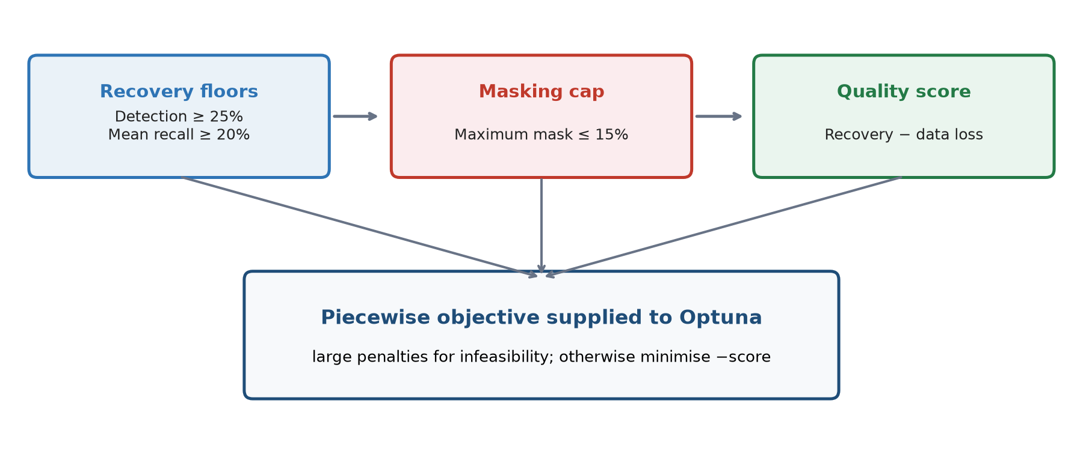
Figure 5. Feasibility is established before the ordinary quality score can win.

7.1 Recovery and data-loss scores
Recovery score = 0.45 F̄ + 0.35 R̄toy + 0.20 D
Data loss = 0.50 M̄ + 0.10 min(FP̄, 1)
Score S = recovery score − data loss

The recovery score gives its largest weight (45%) to F̄ because F rewards accurate and complete pixel coverage simultaneously. Mean toy recall contributes 35%, ensuring every toy matters equally, and detection rate contributes 20%, rewarding the number that cross the 50% recovery threshold. In data loss, M̄ has coefficient 0.50 and FP̄ has coefficient 0.10; FP̄ is capped at 1 defensively. These terms refine the ranking once the recovery floors and masking cap have been considered.

7.2 Piecewise minimisation objective
Let δD = max(0, 0.25 − D), δR = max(0, 0.20 − R̄toy), δM = max(0, Mmax − 0.15)
If no incremental pixels, D < 0.25, or R̄toy < 0.20: Objective = 50 + 20δD + 20δR (+50 if no incremental pixels)
Else if Mmax > 0.15: Objective = 10 + 100δM + data loss − recovery score
Else: Objective = −S

Optuna minimises this objective. The large constants create three regimes. Recovery-infeasible configurations are worst. Configurations that recover enough toys but exceed the masking cap are still penalised. Only fully feasible configurations receive the negative quality score, so a good feasible solution is preferred to any cap-violating one.
Regime | Condition | Effect on search
Recovery infeasible | D < 25%, R̄toy < 20%, or no incremental mask | Large objective beginning at 50
Mask infeasible | Recovery floors met but Mmax > 15% | Objective beginning at 10 plus 100× cap excess
Feasible | Recovery floors and cap all met | Objective = −score; best score becomes most negative

8. Worked example
Assume a parameter set produces D = 0.32, R̄toy = 0.29, F̄ = 0.24, M̄ = 0.07, FP̄ = 0.05 and Mmax = 0.14. It meets both recovery floors and the 15% cap.
Recovery score = 0.45(0.24) + 0.35(0.29) + 0.20(0.32) = 0.2735
Data loss = 0.50(0.07) + 0.10(0.05) = 0.0400
S = 0.2735 − 0.0400 = 0.2335; therefore Objective = −0.2335

If the same result had Mmax = 0.18, it would enter the mask-infeasible regime. Its cap excess would be 0.03 and the objective would become 10 + 100(0.03) + 0.0400 − 0.2735 = 12.7665. This is deliberately much worse than any feasible negative objective.

9. Training objective versus held-out acceptance
Important distinction
The optimisation’s recovery floors are not the final scientific success criteria. They prevent unproductive trials; the untouched validation seeds test a stricter target.

Measure | Training feasibility floor | Held-out acceptance target
Toy detection rate | ≥ 25% | ≥ 50%
Mean toy recall | ≥ 20% | ≥ 30%
Maximum displayed-frame masking | ≤ 15% | ≤ 15%
Galaxy/seed cases with ≥1 recovered toy | Not a training gate | ≥ 80% of cases

The distinction explains how Optuna can find a valid training configuration while the final experiment still fails the 50% held-out detection goal. A configuration that generalises at approximately 25% detection can satisfy the optimisation floor but not the scientific acceptance test.

10. Practical interpretation
- High detection with excessive Mmax indicates aggressive masking rather than a usable solution.
- Low detection and low recall indicate that MTObjects is not recovering enough injected structure.
- Adequate detection but low mean recall indicates marginal, incomplete toy coverage.
- A low mean masked fraction does not override a cap violation in a single displayed frame.
- High recall with low precision produces a modest F-score and indicates an over-broad mask.
- A high FP̄ means the method is removing a substantial fraction of non-toy image area.
- A negative objective value indicates a fully feasible training result; more negative is better.

11. Methodological source
Definitions and coefficients in this guide are taken from the implemented code used for the revised 22-clean-galaxy, displayed-frame optimisation:
Item | Implementation source
Metric implementation | Foreground Masking/Optimisation/paired_toy_common.py — evaluate_mask
Objective implementation | Foreground Masking/Optimisation/optimise_toy_objects_MTObjects.py — aggregate_score
Held-out acceptance | Foreground Masking/Optimisation/evaluate_mtobjects_multiseed_winner.py
Metric version | paired-toy-metrics-displayed-frame-v2
Recorded software revision | ebf8733bf8988733346e4797b0e7498bf03caf8f

